EXERCISE-2

Hello World RESTful Web Service

Code:

pom.xml
<?xml version="1.0" encoding="UTF-8"?>
<project xmlns="http://maven.apache.org/POM/4.0.0"
xmlns:xsi="http://www.w3.org/2001/XMLSchema-instance"
xsi:schemaLocation="https://maven.apache.org/POM/4.0.0 https://maven.apache.org/xsd/maven-4.0.0.xsd">
<modelVersion>4.0.0</modelVersion>
<parent>
<groupId>org.springframework.boot</groupId>
<artifactId>spring-boot-starter-parent</artifactId>
<version>3.5.4</version>
<relativePath/>
</parent>
<groupId>com.cognizant</groupId>
<artifactId>springlearn</artifactId>
<version>0.0.1-SNAPSHOT</version>
<properties>
<java.version>21</java.version>
</properties>
<dependencies>
<dependency>
<groupId>org.springframework.boot</groupId>
<artifactId>spring-boot-starter-web</artifactId>
</dependency>
</dependencies>
<build>
<plugins>
<plugin>
<groupId>org.springframework.boot</groupId>
<artifactId>spring-boot-maven-plugin</artifactId>
</plugin>
</plugins>
</build>
</project>

Application properties
server.port=8083

HelloController.java
package com.cognizant.springlearn.controller;
import org.slf4j.Logger;
import org.slf4j.LoggerFactory;
import org.springframework.web.bind.annotation.GetMapping;
import org.springframework.web.bind.annotation.RestController;
@RestController
public class HelloController {
private static final Logger LOGGER =
LoggerFactory.getLogger(HelloController.class);
@GetMapping("/hello")
public String sayHello() {
LOGGER.info("Start");
LOGGER.info("End");
return "Hello World!!";
}
}

SpringLearnApplication.java
package com.cognizant.springlearn;
import org.springframework.boot.SpringApplication;
import org.springframework.boot.autoconfigure.SpringBootApplication;
@SpringBootApplication
public class SpringLearnApplication {
public static void main(String[] args) {
SpringApplication.run(SpringLearnApplication.class, args);
}
}

Output:

1: Spring Boot Application Startup
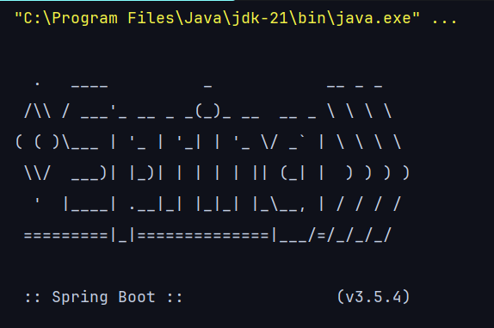

2: Browser Request

URL-http://localhost:8083/hello

Response:
